LIMIT REFERENCE POINTS AND WILD SALMON POLICY RAPID STATUS SUMMARY:

2023 FRASER PINK SALMON-ODD STOCK MANAGEMENT UNIT

Executive Summary
There is one CU in the Fraser Pink SMU and it is designed Green, placing this SMU above the LRP in terms of WSP rapid status (Figures 1 & Tables 3 - 5).
The Fraser Pink-Odd CU was assessed as Green based on its recent generational average (9.6 Million) being above the upper Absolute-Abundance threshold (5.17 Million).

Context
A key recommendation from a CSAS peer review process on Pacific Salmon Limit Reference Points (LRPs) is ‘CU [conservation-unit] status-based LRPs’ be used to meet the Fish Stocks provisions of the Fisheries Act (DFO 2022; Holt et al. 2023a, 2023b), which was supported nationally (DFO 2023). LRP's are assessed for Stock Management Units (SMUs), which can include one or more conservation units (CUs) (i.e., CUs are nested within SMUs). Using this approach, serious harm to a SMU is identified when any component CU zone drops into the Wild Salmon Policy (WSP) Red zone. Under this definition, the CU status-LRP is ‘100% of CUs with statuses above Red status’. The implications are that if a single CU is the Red status zone, the SMU is assessed as being below its LRP, which in turn triggers a DFO rebuilding plan for the SMU.

Forewords
Please fill in with perspectives or values that are not captured through the Rapid Status Assessment algorithm. Include whom the forewords should be attributed to (may be a group or individuals).

Data
There is one CU within the Fraser Pink Salmon-Odd SMU: Fraser Pink0OddA (PKO-1) (Table 1). The data sets used in this assessment are documented in (Grant et al. 2014) and were updated through 2023 with data form the Pacific Salmon Commission. It was determined that these data cannot be used for the absolute abundance metric, though can be applied to the relative abundance metric. Fraser Pinks return in odd years, so status assessments are conducted for odd years only. Pink even year returns are negligible, and therefore, there is no corresponding Fraser Pink CU for these years.
Spawner abundance methods have changed over the time series, with no inter-calibration between years (Grant et al. 2014) (Table 1). Since 1993, spawner abundances are not available for individual Fraser tributaries. Therefore, the underlying distribution of spawners cannot be determined. Spawner distribution may be particularly important for the Fraser Pink CU, given their broad distribution in the Fraser watershed. Fraser Pink salmon have recently been observed in several tributaries of the upper Fraser River where they haven’t been consistently observed for many years. The broad distribution throughout the Fraser River likely increases the uncertainty of the relative-abundance benchmarks as there is potential stock structure that is currently unaccounted for.
Table 1. Conservation Units included in this Stock Management Unit and lists of the most abundant populations within each Conservation Unit.
CU No# | CU name | Populations
PKO-1 | Fraser Pink-Odd | Spawner abundance methods conducted in odd years changed over the time series (Grant et al. 2014):  1961-1991: stream-specific methods (Lower Fraser; Fraser Canyon; Upper Fraser; Seton-Anderson; Thompson; Harrison; Vedder-Chilliwack)  1993-2001: system-wide mark recaptures  2003-2007: indirect system-wide test-fishery estimates  2009-2023: system-wide hydroacoustic estimates

Relative Abundance Benchmarks: Relative abundance lower (S_{gen}: recovery to spawners at maximum sustainable yield (S_{MSY})) and upper (80% S_{MSY}) benchmarks for the Fraser Pink Odd return year SMU/CU are presented in Table 2 (Glaser et al., In press).
Table 2. Relative abundance-based benchmarks and probability levels for the Fraser Pink SMU/CU (80% S_{MSY} = upper benchmark; S_{gen} = lower benchmark). The median (50% Interval) are the values used in the WSP rapid status algorithm.
 |  |  |  | Credible Intervals (values in millions of fish)
CU | Benchmark | Mean | SD | 5% | 10% | 25% | 50% | 75% | 90% | 95%
Fraser Pink | S_{gen} | 2.0 | 0.9 | 1.0 | 1.1 | 1.4 | 1.8 | 2.4 | 3.2 | 3.8
Fraser Pink | 80% S_{MSY} | 4.7 | 1.3 | 3.5 | 3.7 | 4.1 | 4.7 | 5.4 | 6.5 | 7.6

Rapid Status Summary
Stock Management Unit (SMU) Limit Reference Point (LRP) status based on expert consensus
There is one CUs in the Fraser Pink SMU and it is designed Green, placing this SMU above the LRP in terms of WSP rapid status (Figures 1 & Tables 3 - 5).
Fraser Pink Odd Year spawner abundance increased from the 1960s to 2000s and has since been variable. In 12 out of the last 15 years, the preliminary WSP Rapid Status’ have been Green, while the remaining three years were assessed as Yellow. The Rapid Status for 2023 is currently Green due to the spawner abundance in 2023 being greater than the upper Relative-Abundance threshold.
Summarize any additional information and comments from the expert review.
Future work: [pending an expert review]
Table 3. WSP rapid statuses for 2023: The WSP rapid status algorithm was used to assess annual statuses for the Fraser Pink CU (details provided in DFO 2024; Pestal et al. 2023).
CU # | CU Name | WSP Rapid Status (2022) | WSP rapid status node
 | Fraser Pinks | GREEN,  HIGH CONFIDENCE | The recent year’s status (2023) is designated Green with High confidence. The recent generational average (9.6 Million) cannot be compared to the Absolute Abundance algorithm, but falls above the Relative-Abundance metric upper threshold (5.17 Million) (node 36) (Figures 1-3; Table 4). This status has been Green from 1995 to 2023, with the exception of a few years, which were Amber (1997, 1999 & 2017). After a period of high production in the mid-1990s, Fraser Pinks escapements declined, which resulted in a Red percent change (three generation trend) metric for several years. In recent years, however, escapement has increased and the percent change metric is currently Green. No WSP integrated status has been completed for this CU previously.

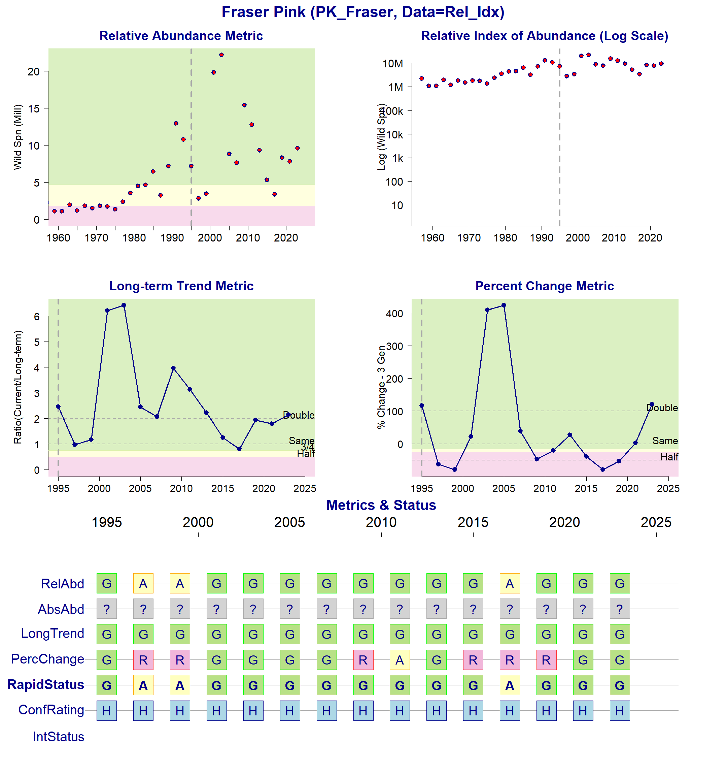
Figure 1: Metrics and Status for Fraser Pink (PKO-1). The four top panels show the four standard WSP metrics, calculated based on the available time series of spawner abundances. Where appropriate and available, benchmarks are provided, and figures are coloured red, amber or green to correspond to values that fall in the corresponding Red, Amber or Green status zones for each metric. The bottom panel summarizes the status for each individual metric from 1995 to 2023, and shows the resulting rapid status for the CU with a confidence rating. No past WSP integrated status assessments have been conducted.

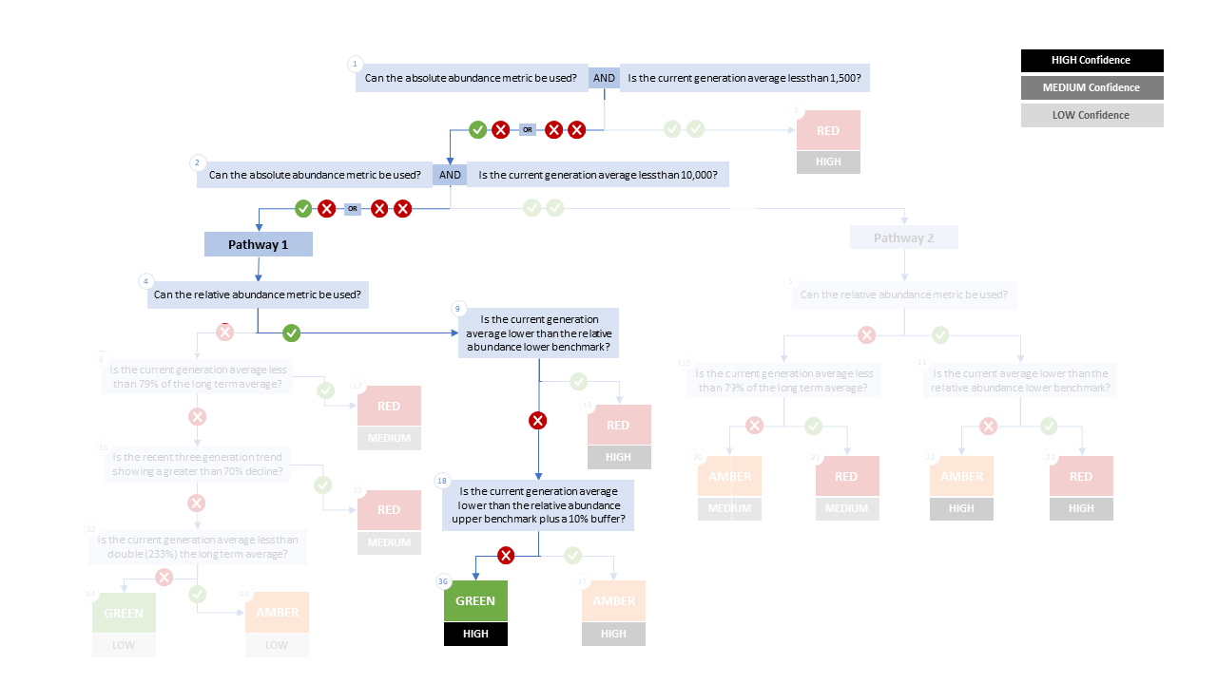

Figure 2. Algorithm pathway taken to assess status for Fraser Pink in 2023. The absolute abundance metric cannot be used for Fraser Pinks, since escapements are considered indices of abundances. The relative abundance metric can be used (node 4). The current generation escapement (2023) does not fall below either the lower (Sgen) or upper (80% Smsy) thresholds for this metric. Status for this CU is therefore designated as Green with High confidence at Node 36.

Table 4. Decision tree path given data and metric values for Fraser Pink in 2023; this aligns with Figure 2 above. For each node, the algorithm decision is made by comparing the CUs current metric value to the metric threshold and answering Yes or No, running through sequential nodes and decisions until the final WSP rapid status for that CU and year is reached.
Node | Metric | Metric Threshold | CUs Current value | Decision
1 | Absolute Abundance | <1,500 | - | NO, NA
2 | Absolute Abundance | <10,000 | - | NO, NA
4 | Relative Abundance | Available? | - | YES
9 | Relative Abundance | <1.8 M | 9.6 M | NO
18 | Relative Abundance | <5.17 M | 9.6 M | NO
36 | FINAL STATUS NODE |  |  | GREEN
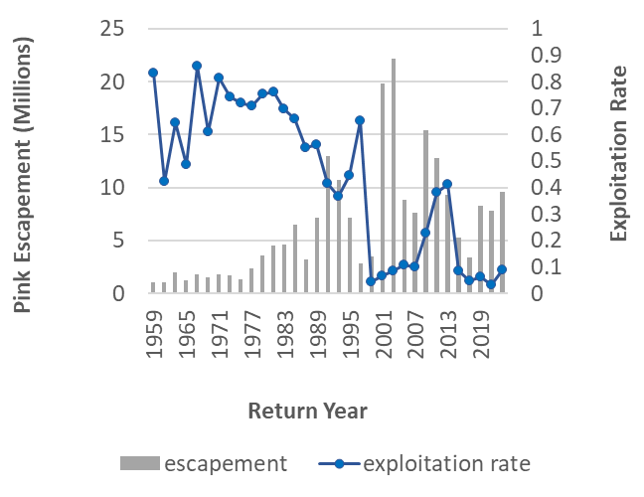

Figure 3. Escapement and exploitation rates for Fraser Pink (odd years). This includes years 1959 to 2023.

Cited and other Key References
DFO. 2015. Wild Salmon Policy status assessment for conservation units of Interior Fraser River coho (Oncorhynchus kisutch). Can. Sci. Advis. Sec. Sci. Advis. Rep. 2015/022: 12 pp. Available from https://waves-vagues.dfo-mpo.gc.ca/Library/364851.pdf
DFO. 2022. Methodologies and guidelines for defining limit reference points for Pacific Salmon. CSAS SAR 2022/030. pp. 16. Available from https://www.dfo-mpo.gc.ca/csas-sccs/Publications/SAR-AS/2022/2022_030-eng.html
DFO. 2023. Science advice on guidance for limit reference points under the fish stocks provisions. Can. Sci. Advis. Secr. Sci. Advis. Rep. 2023/009(February). Available from https://publications.gc.ca/collections/collection_2023/mpo-dfo/fs70-6/Fs70-6-2023-009-eng.pdf
DFO. 2024. Rapid status approximations for Pacific salmon derived from integrated status assessments under DFO’s Wild Salmon Policy. CSAS Sci. Resp. 2024/004: 42 p. https://www.dfo-mpo.gc.ca/csas-sccs/Publications/ScR-RS/2024/2024_004-eng.pdf
Glaser, D.M., Connors, B.M., Dionne, K., and Huang A.M. In Press. Estimating Precautionaly Approach reference points and assessing consequences of harvest control rules for Fraser River Pink Salmon (Oncorhynchus gorbushca). DFO Can. Sci. Advis. Sec. Res. Doc. 202#/nnn. Iv + 13 p.
Grant, S.C.H., Townsend, M., White, B., and Lapointe, M. 2014. Fraser River Pink Salmon (Oncorhynchus gorbuscha) data review: inputs for biological status and escapement goals. Final project report to Southern Boundary Restoration and Enhancement Fund. Available from https://www.psc.org/download/509/information/8561/s13-i06-fraser-pink-salmon-oncorhynchus-gorbuscha-escapement-goals-data-report.pdf
Holt, C.A., Holt, K., Warkentin, L., Wor, C., Connors, B., Grant, S., Huang, A.-M., and Marentette, J. 2023a. Guidelines for Defining Limit Reference Points for Pacific Salmon Stock Management Units. DFO Can. Sci. Advis. Sec. Res. Doc. 2023/009. iv + 66 p. Available from https://publications.gc.ca/collections/collection_2023/mpo-dfo/fs70-5/Fs70-5-2023-009-eng.pdf
Holt, K., Holt, C.A., Warkentin, L., Wor, C., Davis, B., Arbeider, M., Bokvist, J., Crowley, S., Grant, S.C.H., Luedke, W., McHugh, D., Picco, C., and Will, P. Van. 2023b. Case Study Applications of LRP Estimation Methods to Pacific Salmon Stock Management Units. Can. Sci. Advis. Sec. Res. Doc. 2023/010: iv + 129. Available from https://www.dfo-mpo.gc.ca/csas-sccs/Publications/ResDocs-DocRech/2023/2023_010-eng.html
Pestal, G., MacDonald, B.L., Grant, S.C.H., and Holt, C.A. 2023. State of The Salmon: rapid status assessment approach for Pacific salmon under Canada’s Wild Salmon Policy. Can. Tech. Rep. Fish. Aquat. Sci. 3570: xiv + 200 p. Available from https://waves-vagues.dfo-mpo.gc.ca/library-bibliotheque/41207890.pdf

Appendix A: WSP rapid status approach details

The decision tree sequence is as follows (see Figure A1; Table A1, A2):
- The first question is whether or not a CU has a current absolute abundance value, and if so, whether or not this value falls below the lower threshold of 1,500 (which adds a buffer to Committee on the Status of Endangered Wildlife in Canada (COSEWIC) Criterion D1 for small population size of 1,000). If the answer to this question is Yes, then the CU is assigned Red (node 3), with High confidence.
- If the answer to the first question is No, then the second question is whether or not the CU has a current absolute abundance value, and if so, whether or not the current abundance is below the upper threshold of 10,000, which is COSEWIC's Criterion C upper benchmark. This second question splits the decision nodes into two Pathways: Pathway 1 (No to this question) and Pathway 2 (Yes to this question).
  - Pathway 1: is where a CU either does not have a current absolute abundance value, or has these data, and it falls above the upper threshold for this metric. This pathway is split with the question: can this CU be assessed with a relative abundance metric. If the answer is Yes, a Red (nodes 19), Amber (nodes 37) or Green (node 36) WSP rapid status is assigned, with High confidence, depending on where the current abundance value falls relative to this metric’s lower and upper thresholds. If the answer is NO, then comparisons are made between the CU’s current abundances and percent change to thresholds for these metrics, which assign a Red with Medium confidence, or Green or Amber with Low confidence status.
  - Pathway 2: is where a CU has absolute abundance data, and these abundances fall between the lower and upper thresholds. In this pathway, absolute abundances restrict WSP rapid statuses to only Amber or Red. This pathway is split with the question: can this CU be assessed with a relative abundance metric. If the answer is Yes, an Amber (node 22) with Medium confidence, or Red (node 23) with High confidence, is assigned, depending on whether the CU’s current abundance value falls above the relative abundance metric lower threshold or below. If the CU cannot be assessed with a relative abundance metric, then it is compared to the lower threshold of the Long-Term trend metric and assigned Amber (node 20) with Medium confidence if above, or Red (node 21) with Medium confidence if below.

Table A1. Biological status zones under the Wild Salmon Policy (WSP).

Status |  | Definition
 | Red | Poor status CU facing an imminent threat of extinction [revised definition, given alignment with COSEWIC Endangered statuses]
 | Amber | “While a CU in the Amber zone should be at low risk of loss, there will be a degree of lost production. Still, this situation may results when CUs share risk factors with other, more productive units”. Aligns with COSEWIC Threatened and Special Concern statuses.
 | Green | “identif[ies] whether harvest are greater than the level expected to provide on an average annual basis, the maximum annual catch for a CU, given existing conditions…there would not be a high probability of losing the CU”. Aligns with COSEWIC Not at Risk statuses.
 | DD | Data deficient. CUs have been designated as DD if there is no data available, or if the available data is insufficient for calculating status metrics (after quality control).

Table A2. WSP rapid status Learning Tree 3 status assignments by node (see Figure 1). This table presents the decisions in Learning Tree 3 that led to Red or Amber or Green status assignments; status outcomes depend on the pathway and decisions made. The final node that corresponds to the status assignment is presented below (see Figure 1).
Node | Status | Rule
Node3 | Red | Data Type is Absolute Abundance AND Absolute Abundance < 1,500
Node17 | Red | Data Type is Relative Index OR Absolute Abundance ≥ 1,500;  then Data Type is Relative Index OR Absolute Abundance ≥ 10,000;  then no Relative Abundance lower benchmark; then Long Term Trend < 79%
Node19 | Red | Data Type is Relative Index OR Absolute Abundance ≥ 1,500;  then Data Type is Relative Index OR Absolute Abundance ≥ 10,000  then have Relative Abundance lower benchmark;  then Relative Abundance < Relative Abundance lower benchmark
Node20 | Amber | Data Type is Relative Index OR Absolute Abundance ≥ 1,500;  then Data Type is Absolute Abundance AND Absolute Abundance<10,000;  then no Relative Abundance lower benchmark; then Long Term Trend ≥ 79%
Node21 | Red | Data Type is Relative Index OR Absolute Abundance ≥ 1,500;  then Data Type is Absolute Abundance AND Absolute Abundance<10,000;  then no Relative Abundance lower benchmark; then Long Term Trend < 79%
Node22 | Amber | Data Type is Relative Index OR Absolute Abundance ≥ 1,500;  then Data Type is Absolute Abundance AND Absolute Abundance<10,000;  then have Relative Abundance lower benchmark;  then Relative Abundance ≥ Relative Abundance lower benchmark
Node23 | Red | Data Type is Relative Index OR Absolute Abundance ≥ 1,500;  then Data Type is Absolute Abundance AND Absolute Abundance<10,000;  then have Relative Abundance lower benchmark;  then Relative Abundance < Relative Abundance lower benchmark
Node33 | Red | Data Type is Relative Index OR Absolute Abundance ≥ 1,500;  then Data Type is Relative Index OR Absolute Abundance ≥ 10,000;  then no Relative Abundance lower benchmark;  then Long Term Trend ≥ 79%; then Percent Change < -70
Node36 | Green | Data Type is Relative Index OR Absolute Abundance ≥ 1,500;  then Data Type is Relative Index OR Absolute Abundance ≥ 10,000  then have Relative Abundance lower benchmark;  then Relative Abundance ≥ Relative Abundance lower benchmark;  then Relative Abundance ≥ Relative Abundance upper benchmark x 1.1
Node37 | Amber | Data Type is Relative Index OR Absolute Abundance ≥ 1,500;  then Data Type is Relative Index OR Absolute Abundance ≥ 10,000  then have Relative Abundance lower benchmark;  then Relative Abundance ≥ Relative Abundance lower benchmark;  then Relative Abundance < Relative Abundance upper benchmark x 1.1
Node64 | Green | Data Type is Relative Index OR Absolute Abundance ≥ 1,500;  then Data Type is Relative Index OR Absolute Abundance ≥ 10,000;  then no Relative Abundance lower benchmark;  then Long Term Trend ≥ 79%; then Percent Change < -70  then Long Term Trend ≥ 233
Node65 | Amber | Data Type is Relative Index OR Absolute Abundance ≥ 1,500;  then Data Type is Relative Index OR Absolute Abundance ≥ 10,000;  then no Relative Abundance lower benchmark;  then Long Term Trend ≥ 79%;  then Percent Change < -70  then Long Term Trend < 233

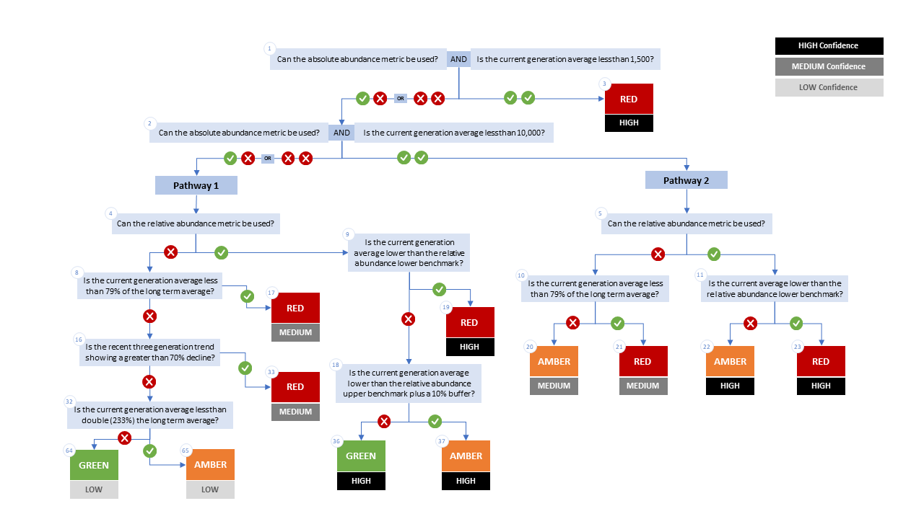

Figure A1. WSP rapid status decision tree (Table 2 includes written descriptions). To assess a CU, metric values are compared to thresholds presented at each decision point. Yes or No answers split each path of the decision tree, terminating at WSP rapid status assignments. The different splits are identified as nodes: 1 to 65. Pathway 1 is taken when the CU has no absolute abundance data, or these data exist, but fall above its upper threshold of 10,000. Pathway 2 is taken when the CU has absolute abundance data and these fall under its upper benchmark of 10,000.

Appendix B: Meeting History and Participants
Tables and summaries of meetings and participants, specifically participants who identified as a subject matter expert for one or more CUs.

The values presented here are slightly different than what will be published in the publication due to minor modifications in the modelling requested at Sprint Week and should not affect the 2023 Rapid Status.
Consensus: general agreement of group as a whole, or absence of evidence-based opposition to conclusions. Determined by the “weight of evidence” (scientific data, information, and analysis ) where multiple results are reported. In the event of disagreements, equally plausible conclusions can be reported. Dissenting views must be clearly described in the narrative.

